**Department of Information and Communications Technology**

**(Tsing Yi)**

1. Objectives

In this project you are asked to :

* build a web application which provides different functions for *customers*, *suppliers* and the company staff (includes an *administrator* and *truck drivers*)
* apply software development skills to develop a web site which is user-friendly, interactive, robust and easy to maintain
* apply the knowledge you learned in this module to solve tasks which require your skills in HTML, CSS, JavaScript, PHP and simple SQL commands

1. A simplified scenario to show how the web application will be used
   1. There are four types of users for this Online Shop application :   
      customers, suppliers, administrator and truck drivers.
   2. Customers can select products and place orders from the web site.
   3. Suppliers can post their products information in the web site.
   4. Drivers can maintain their personal schedules and display delivery jobs assigned to them by the system.
   5. An administrator can maintain some database tables and display customer orders.
2. Functions for the site administrator

|  |  |
| --- | --- |
|  | Done By |
| * 1. An administrator can log in the system to access functions only accessible by administrator. Also, an administrator can log in simultaneously from more than one machine. |  |
| * 1. An administrator can maintain (add/change/delete) information of products category. |  |
| * 1. An administrator can maintain (add/change/delete) district information. |  |
| * 1. An administrator will use Dreamweaver to create two stylesheets for two different screen layouts (e.g. desktop PC view, printer friendly view, hand-held device view) which can be selected by the users. Store the user's choice in cookies. |  |
| * 1. An administrator can display customer orders by different selection criteria :   + by product code   + by product category   + by district   Moreover, the displayed sales order can be sorted by any two columns (or fields) in ascending or descending order |  |

1. Functions for the Driver

|  |  |
| --- | --- |
|  | **Done by** |
| * 1. A truck driver can log in the system to access functions only accessible by truck drivers. However a truck driver cannot log in simultaneously from more than one machine. |  |
| * 1. A truck driver can mark the available dates (i.e. jobDate) and preferred service region (HK Island/ Kowloon / New Territories) in his/her personal schedule (i.e. *Schedule* table).  To facilitate data entry, two input methods should be provided :   + data can be inputted day by day,   + data can be copied / repeated for several weeks (e.g. every Wed for next 3 weeks) |  |
| * 1. The personal schedule detail is read-only if a delivery job is already assigned to the truck driver for that day. |  |
| * 1. The products for each customer order (i.e. *CustOrder* table) will only be delivered once. Customer orders will be assigned to the truck drivers automatically by the system base on the available dates and service region in the personal schedule set by each driver.  If more than one truck driver is available to deliver the products, the job assignment should be fairly distributed to truck drivers.   Create a PHP function named "**matchSchedule**(*ordNo*, *jobDate*, *distNo*)" which can automatically assign a customer order to a driver. |  |
| * 1. A truck driver can enquire the jobs assigned to him/her. |  |

1. Functions for Customers

|  |  |
| --- | --- |
|  | Done by |
| * 1. *Any user* can search products by three different data :   + product code,   + category,   + stock quantity   Decide *wisely* what information should be displayed for the search result and *what function* a customer can perform after selecting a product from the search result. |  |
| * 1. User can register at the web site as a customer. |  |
| * 1. Customer should log in before placing any order. However, a customer cannot log in simultaneously from more than one machine. |  |
| * 1. Customers can *add* products into or *remove* products from a shopping cart. |  |
| * 1. Before an order is created from the shopping cart, a customer may change the *default* delivery address. The system should ensure the stock quantity can satisfy the quantity demand for each product in an order. |  |
| * 1. The delivery date of an order defaults to *2 days after the order date*. When an order is created, the system must call the PHP function named "**matchSchedule**(*ordNo*, *jobDate*, *distNo*)" to automatically assign a customer order to a driver. |  |

1. Functions for Suppliers

|  |  |
| --- | --- |
|  | **Done by** |
| * 1. A supplier can log in the system to access functions only accessible by suppliers. However a supplier cannot log in simultaneously from more than one machine. |  |
| * 1. A supplier can update its company information. |  |
| * 1. A supplier can maintain (add/change/delete) its own product information, however a product *cannot be deleted* if it is found in any customer order. |  |
| * 1. A supplier can view the sales summary by category (*catNo*), district (*distNo*) and gender (*custGender*). |  |
| * 1. Each product may associate with a product photo which can later *be replaced by a new photo*. Remove the old photo from the server after replacement. |  |

1. Form your assignment group

Each student may choose to form an assignment group which consists of students from same group of the same course, however, **the maximum number of students in each group is 4 (should not less than 3)**. I strongly recommend you to form a group to complete this assignment as you can benefit from sharing skills/codes amongst your members, and you can learn to plan, coordinate, and integrate work done by each member.

|  |  |
| --- | --- |
| **全班學生人數** | **最理想分組組合** |
| 25 | 3人組(共3組) + 4人組(共4組) |
| 26 | 3人組(共2組) + 4人組(共5組) |
| 27 | 3人組(共1組) + 4人組(共6組) |
| 28 | 3人組(共0組) + 4人組(共7組) |
| 29 | 3人組(共3組) + 4人組(共5組) |
| 30 | 3人組(共2組) + 4人組(共6組) |
| 31 | 3人組(共1組) + 4人組(共7組) |
| 32 | 3人組(共0組) + 4人組(共8組) |
| 33 | 3人組(共3組) + 4人組(共6組) |
| 34 | 3人組(共2組) + 4人組(共7組) |

1. Additional requirements of your project
   1. Your web site should only use PHP as the server-side programming language (i.e. not ASP, ASP.NET, JSP, servlet etc.), however, you may use JavaScript and CSS for specific purposes. The database server used must be mySQL (version 5.0 or above).
   2. In your PHP code, you must ensure to use the following *parameter values* for the following mySQL database functions :  
       $conn = *mysql_pconnect*($hostname_conn, $username_conn, $password_conn);  
       *mysql_select_db*($database_conn, $conn);  
      set to the values below :  
       $hostname_conn = "**127.0.0.1**";  
       $database_conn = "**projectDB**";  
       $username_conn = "**root**";  
       $password_conn = "";
2. Items to submit ( will deduct a maximum of 30 marks if any of the following items is not submitted)
   1. A ***CD-ROM*** or ***DVD-ROM*** which stores a ***softcopy of all files*** for the whole web site. All files must be stored in non-compressed format (no .zip or .rar files please !)
   2. provide a SQL script file ***CreateProjectDB.sql*** to let the lecturer to re-create the database and test data
   3. for the SQL script file ***CreateProjectDB.sql***, it must contain *CREATE TABLE* commands to setup the database tables in **projectDB** database. Include necessary *INSERT* statements to add additional sample records you want to provide. The following is a sample SQL script :

drop database IF EXISTS **projectDB**;

You must specify the **InnoDB** engine for a database table :

ENGINE = **InnoDB**

Full explanation of different ***mySQL database engines*** :

<http://dev.mysql.com/doc/refman/5.0/en/storage-engines.html>

create database **projectDB** character set utf8;

use **projectDB**;

drop table IF EXISTS **Users**;

Create table **Users** (

userName Varchar(30) NOT NULL,

userPswd Varchar(10),

Primary Key (userName)) **ENGINE = InnoDB**;

INSERT INTO **Users** (userName, userPswd) VALUES

('admin1', 'secret1'),

('admin2', 'secret2');

* 1. a ***printout*** of a short report (1 to 5 pages only) which explains the good designs in your web site. For example, how do you apply CSS, JavaScript, cookies in your design to make your web site easy to maintain and more user-friendly, or how you can improve the security of the web site.
  2. a ***printout*** of another short report (1 to 2 pages only) which describes the set up procedure of your web site. E.g. describe clearly what is the *alias* to be used, what parameters should be changed in the configuration file *php.ini* etc.
  3. a ***demonstration*** of your completed web site should be recorded by a a *30-day free-trial software Camtasia Studio 8.0* (<http://www.techsmith.com/camtasia.html>). You should save different parts of your demonstration into different **.mp4** files. In the report, write in 1 page to briefly describe the main content of each demo video file you have created. The video files will facilitate the lecturer to have in-depth evaluation of your web application. Here are some online tutorials for **Camtasia Studio 7** <http://www.techsmith.com/tutorial-camtasia-current.html> :  
     ***Getting Started: 1 - Record Full Screen*** :   
     <http://www.techsmith.com/tutorial-camtasia-record-full-screen.html>   
     ***Produce and Share an MP4 Video*** *:*<http://www.techsmith.com/tutorial-camtasia-produce-and-share-mp4-video.html>

1. Assessment criteria of your project
   1. The functions implemented can perform correctly in *general* and *special* situations
   2. *Enough detail* of database records and extensive *data validation*
   3. Techniques used to promote *code reusability* (e.g. share common PHP/JavaScript/CSS files amongst different web pages) and *standardize the user-interface* of the web pages
   4. Coding style (e.g. indentation, meaningful variable names, modularity by user-defined functions etc.) and meaningful *comment* is added to program codes
   5. *Creativity* to enhance implemented functions so that they become easy to use, more interactive to the users or can handle some problems in real life situation
   6. Screen design and overall *quality of the integration* of different functions in the web site
2. A guideline for web development

It is a step-by-step approach I suggested for inexperienced web developers to develop the web site easily :

* decide what information to be displayed and design a number of web pages in HTML code (not PHP code at this stage) to display the information
* think about the site structure by creating different sub-folders to store files of different purposes (e.g. **images** folder to store image files, **style** folder to store CSS files, **Connections** folder to store files which define the settings for database connection) and design the linkages between the pages. You can easily view the site structure using DW8's site map view
* create HTML web pages (don't add JavaScript so soon) and design the layout with HTML codes and CSS rules. It is a good practice to check your .html files can pass the XHTML validation after you complete a .html file
* when using CSS, it is preferred to create *external CSS files* (stylesheets) which can be reused in other web pages, so that other pages can have consistent formatting
* use DW8's template features which can help you to create a new page with a standard layout and also it provides common editable regions for web pages created from the same template.
* define frameset(s) and navigation bar or menu to link up different pages
* add JavaScript code to produce more interactive behaviours (such as validate data in the form, highlight a table row with different background colour when the mouse move over a table row). It is preferred to use *external JavaScript file* which will be reused in other web pages
* replace hyperlink text with image / button to beautify the links. Dreamweaver can help you to create nice Flash buttons easily
* finally, it comes to the hardest work, that is to convert some of the HTML codes into PHP codes in order to generate dynamic contents from data extracted from database, cookie and PHP pre-defined arrays ($_POST, $_GET, $_COOKIE, $_SESSION, $_FILES, $_SERVER etc.)

1. Penalty for plagiarism

* Each student has to submit his/her own work. Plagiarism (抄襲) will be treated seriously.
* All assignments that have been found involved wholly or partly in plagiarism (no matter these assignments are from the original authors or from the plagiarists) will score ZERO marks. Furthermore, disciplinary action will be followed.

**Late submission will receive ZERO marks**

Because test database data will be given to you during the demonstration :

You are not allowed to change the database structure (i.e. table names, field names and data types etc.) for the given mySQL database.

**Department of Information and Communications Technology**

**(Tsing Yi)**

|  |  |
| --- | --- |
| **ITP4503** | **Internet & Multimedia Applications Development**  **(2014-2015)** |

**Assignment Cover Sheet**

This assignment is submitted to : Tony SIU / Albert Ho / Francis Yuen (* *delete the inappropriate*)

|  |  |
| --- | --- |
| **Number of students in the assignment group :** |  |

|  |  |
| --- | --- |
| **Assignment group no. :**  **( assigned by the lecturer *if any*)** |  |

|  |  |  |  |  |
| --- | --- | --- | --- | --- |
|  | **Course** | **Group** | **Full Name** | **Work Contribution (%) \*\*** |
| e.g | IT114105 | 1A | CHAN Tai Man |  |
|  |  |  |  |  |
|  |  |  |  |  |
|  |  |  |  |  |
|  |  |  |  |  |

** The **Work Contribution** value will determine the mark a student can score in this assignment. The total should be **100%** for the whole group.

Fill in the required information for this assignment cover sheet and put it as the cover page of the envelope which will be submitted by your group

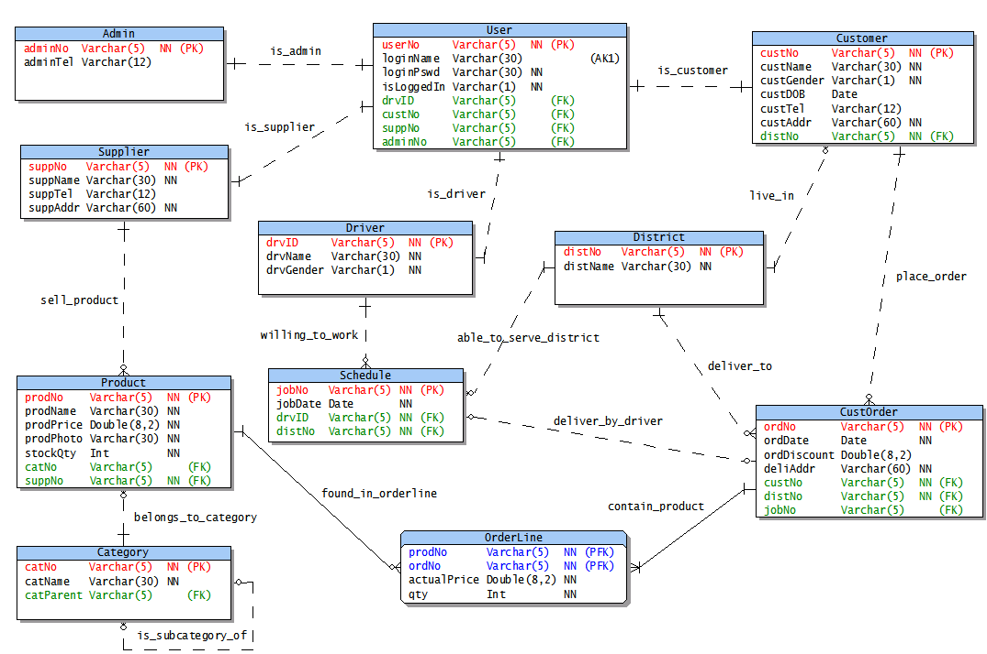

NN

Additional files for the ERD :

* To create the **projectdb** database in mySQL 5.0 database server, either :

1) Unzip **projectdb.zip** to get the set of .frm, .MYD and .MYI files, or

2) Run SQL commands in **createProjectDB.SQL**

Explanation to abbreviations in ERD :

* **PK** : Primary Key
* **FK** : Foreign Key
* **AK1** : Unique Key (value must be unique)
* **PFK** : It serves both as PK and FK
* **NN** : Not Null. The value must not be null